We Outgrew Buffer but Couldn't Afford Hootsuite — Here's the Middle Ground
For a long time, Buffer was exactly what we needed. Clean, simple, no learning curve. You connect your accounts, drop in a post, pick a time, done. When you're a small team just getting into social media seriously, that simplicity feels like a feature.
But somewhere around month eighteen, it started feeling less like simplicity and more like a ceiling.
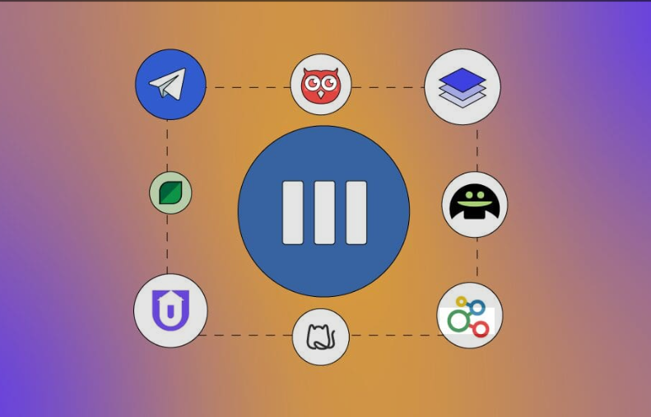
The moment Buffer wasn't enough anymore
We were managing marketing for a mid-sized services setup like Brightflow Studio with a small team and multiple active social media accounts across platforms. As things scaled, our work turned into a proper content system with planned calendars, regular repurposing across formats, and continuous tracking of performance to understand what actually drove clicks and engagement instead of just focusing on posts that looked good on the surface.
Buffer struggled to keep up.
The analytics were surface-level at best. I kept exporting CSVs and building my own reports in a separate spreadsheet — which defeats the point of a tool. The composer worked fine for simple posts, but the moment I wanted to customize a caption for Instagram versus LinkedIn versus Facebook, I was copy-pasting and manually tweaking across three separate post entries. On a busy week, that's an hour I didn't have.
And then there were the platforms we needed to add. Buffer's support for newer or growing networks lagged. We were essentially doing those by hand, which isn't sustainable.
So we started shopping around and exploring Buffer alternatives that could handle our growing needs without jumping straight into enterprise-level pricing.

Why Hootsuite wasn't the answer
Hootsuite is the obvious next step. It's the big name, it has everything, and nearly every "Buffer vs" article eventually points there.
We looked. We opened the pricing page. Then we closed it.
Hootsuite's entry tier now runs around $99 per user per month on annual billing — more if you go month-to-month. Multiply that across three users and you're looking at a significant annual commitment before you've even opened the product. And that tier isn't even where the features we needed lived; the genuinely useful analytics and expanded account limits pushed us toward higher plans that made even less sense for where we were.
To be fair: if you're a large agency or enterprise team, Hootsuite probably earns that price. The social listening tools, the approval workflows for big teams, the depth of reporting — it's built for a different scale than us.
We're not that. We're a focused team that needed something grown-up but not enterprise.
Readmore:https://www.kaggle.com/code/jasminejared/buffer-scheduled-fine-but-left-us-blind-on-analyti?scriptVersionId=325955604

Finding the middle ground
The criteria we ended up with after getting burned by the pricing exercise:
Flat or team-friendly pricing. The per-seat model at Hootsuite's rates was a deal-breaker. We needed something where adding a colleague didn't immediately double the bill.
A composer that actually helps. Not just a text box. Something that makes it easier to write for multiple networks in one go, and that gives you a nudge when the copy isn't quite there.
Real analytics. Not just follower counts and likes — actual engagement trends, best posting times, content that drives action.
Platform coverage that keeps up. We're active on Threads and expanding into Bluesky alongside the core channels. We needed a tool that's keeping pace with where audiences are moving, not one still optimized for the platforms everyone was on five years ago.
That list led us to ContentStudio, and after a few weeks of testing, we moved.


What actually changed
The pricing landed in the range we needed — team members included without the per-seat penalty blowing things up. That alone removed the monthly anxiety of staring at an invoice and calculating whether the tool was earning its keep.
The composer is where I noticed the biggest day-to-day difference. Writing once and tailoring per network inside the same editor sounds like a small thing until you've spent months doing it the manual way. It's genuinely faster, and the AI caption assistance means blank-page paralysis isn't a thing anymore — you've always got a starting point to react to.
Content discovery was a bonus I hadn't really considered. Finding relevant content to share in the same tool I publish from meant one less tab, one less login, one less mental context switch.
And the analytics actually answer questions. I can see what's working without building my own spreadsheet. That's the thing Buffer couldn't give us and Hootsuite wanted to charge enterprise rates to provide.

Who this is and isn't for
ContentStudio hit the middle ground for us specifically because we'd outgrown simplicity but weren't ready to pay for scale we don't need.
If you're a solo creator posting occasionally to two or three platforms, Buffer's simplicity still makes sense — don't over-tool yourself. If you're a 20-person agency with complex approval chains and deep enterprise reporting needs, Hootsuite's pricing might actually be justified by what you get.
But if you're somewhere in the middle — a small team, real volume, real platforms, real need for analytics — that gap is exactly where ContentStudio sits.
Six months in, we haven't looked back. The tool grew with us instead of holding us back, and we didn't have to sign an enterprise contract to get there.
If you hit the same wall with Buffer that we did, it's worth a proper look at this hootsuite alternative before you assume Hootsuite is your only upgrade path.

